A Thing I Hate
Name: Zhenyu Song
Email: zhenyus4@uci.edu
Course: SWE 263P
Date: April 10, 2026
Assignment: A Thing I Hate: The UCI Campus Rec App
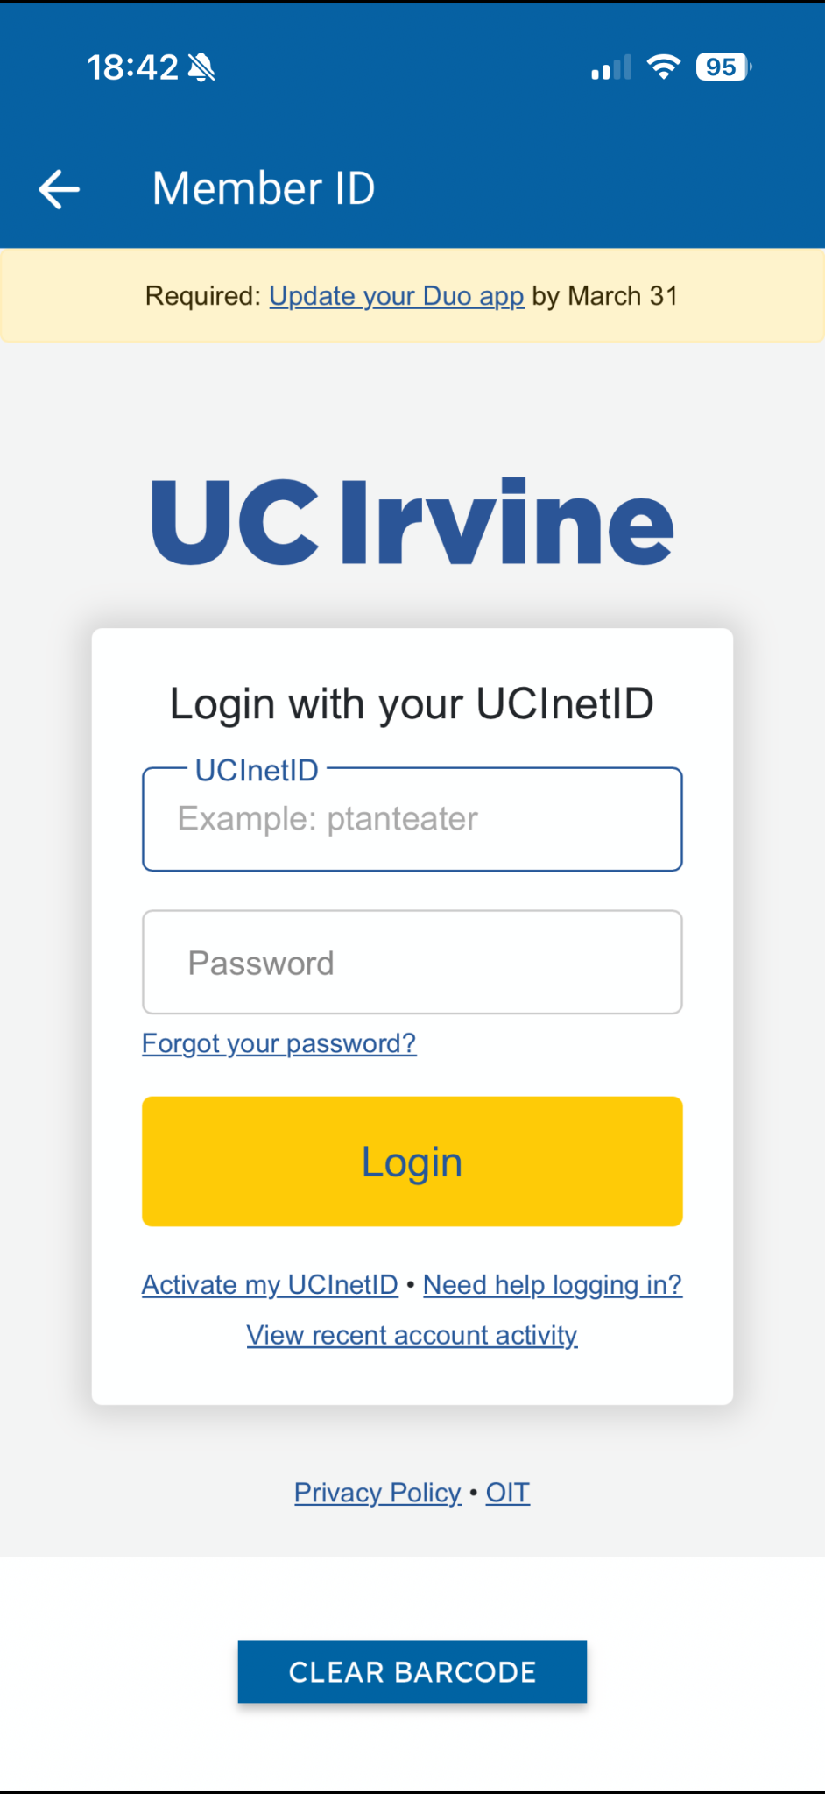
As a student at UCI, I rely heavily on my electronic student ID. We use the UCI Campus Rec Mobile Application to access our digital cards. While having an ID on my smartphone sounds convenient in theory, this app is actually one of the most frustrating interfaces I interact with on a daily basis.
My frustration peaks almost every time I go to the UCI ARC (the campus gym) to work out. When I walk up to the entrance, I need to scan my ID quickly so I do not block the line. However, when I open the app, it almost never shows my electronic ID right away. Instead, it forces me to log in. The app does not seem to cache my login status for a reasonable amount of time (like 30 days or even 24 hours), which means I have to type my username and password from scratch.
To make matters worse, the cellular network just outside the ARC is notoriously weak. After I finally type my credentials and hit the login button, the app takes forever to load. I often end up standing awkwardly near the turnstiles, staring at a loading screen, just waiting for my ID barcode to finally appear. This huge delay greatly ruins my experience.
We can understand why this app is so frustrating by looking at a few design principles from Don Norman’s The Design of Everyday Things and our week 2 lecture slides.
First, the app's design ignores human memory capabilities by relying on "recall" rather than "recognition". As we learned in class, human memory is much better at recognition, while computers are better at recall. By forcing me to remember and type my password every single time I need my ID, the app creates unnecessary cognitive friction. The designers likely implemented this as a strict security "forcing function"—a strong constraint designed to prevent unauthorized access. However, as Norman points out, forcing functions can be a nuisance in normal usage. Because the nuisance value is so high, it makes the everyday task of entering a building painful.
Second, the app suffers from very poor feedback. Norman explains that feedback must be immediate, and even a delay of a tenth of a second can be disconcerting. When the internet connection is poor at the ARC, the app simply hangs. It does not provide informative feedback about the network status. Without proper feedback, I am left wondering if the system is still working on my request or if I need to restart the app.
Finally, the app violates my conceptual model of an ID card. My mental model of an ID is based on a physical card: I pull it out of my wallet, and it is instantly ready to scan. A digital version should offer the same immediate access. Instead, the current system image presents a slow, multi-step gateway.
In conclusion, while security is important, the UCI Campus Rec app fails because it ignores human capabilities and real-world environmental constraints. Implementing a simple login cache and allowing offline access to the barcode would easily solve these frustrating design flaws.

